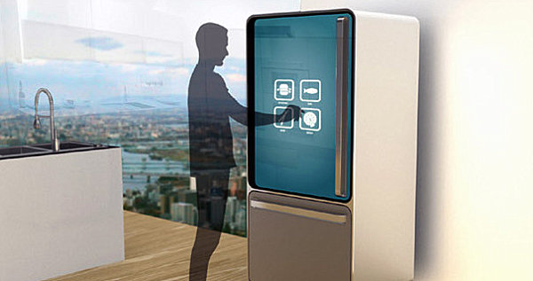

|  |  |
| --- | --- |
|  | Smart Refrigerator  *The first device of the smart kitchen - Seesam* |
|  | Tom Mampaey &  Bernd Verhofstadt  Bachelor Electronics – ICT  Erasmusstudents: Belgium  OAMK - University of Applied Sciences  Jan – May 2015 |

Table of contents:

1. Introduction: 2

2. The project: 2

3. Github: 2

4. The idea’s and brainstorm: 3

- User recognition: 3

o **Fingerprint reader in handheld:** 3

o **Active RFID key-hanger or card:** 3

o **Kinect face-recognition:** 3

o **Face-recognition Raspberry-Pi:** 3

o **Voice-recognition:** 3

o **Motion-detection:** 3

- Product recognition and recommendation: 4

o **Barcode-reader:** 4

o **NFC-tag:** 4

o **Mechanical detection/hatches:** 4

o **LED’s/ LED-strip** 4

- Health-detection: 5

o **Integrated scale:** 5

o **Personal point-system (based on earlier snacks):** 5

o **BMI-calculator:** 5

- Communication/Platform: 5

o **Raspberry Pi:** 5

o **Arduino:** 5

o **Wi-Fi and Ethernet (LAN):** 5

o **Bluetooth:** 5

5. Estimated Gantt-chart: 6

The Annex: 8

Content: 8

Images: 8

# Introduction

We are both third-year students from ‘Artesis Plantijn Antwerp’ in Belgium. When we saw the opportunity to go on Erasmus to Oulu in Finland and do our Bachelor-project there we did everything to make it possible.   
Here we are, and we are very thrilled about the project we finally got!

# The project

The project we are doing is a daughter-project of a bigger project of two years to put some intelligence into the ordinary kitchen (Seesam). We have the privilege to be the first two students to contribute to this project.

As stated in the title, we will delve us into the smart refrigerator!  
Wouldn’t be awesome if your refrigerator knew more about you, your habits and products?  
Well, that’s exactly what we will make for you!  
  
The main idea is to make a refrigerator that will know who’s using it, what he may and what he may not eat and even what’s in the refrigerator. The refrigerator will know this based on the current properties of the user (User-input, Readers, BMI-calculator …)

*This project was given with the purpose to have a mostly practical end result.*

# Acknowledgements

#### Project managers: **Mr. Jussi Kangasoja** ✉ [Jussi.Kangasoja@oamk.fi](mailto:Jussi.Kangasoja@oamk.fi)

#### **Ms. Kaisa Orajärvi** ✉ [Kaisa.orajarvi@oamk.fi](mailto:Kaisa.orajarvi@oamk.fi)

# *Hardware/Software subvention:* **Mr. Henry Hinkula** ✉ [*Henry.Hinkula@oamk.fi*](mailto:Henry.Hinkula@%6f%61%6d%6b%2e%66%69)

# **Ms. Anne Keskitalo**

✉ [*Anne.Keskitalo@oamk.fi*](mailto:Anne.Keskitalo@%6f%61%6d%6b%2e%66%69)

# *Belgian Lectors:*

**Mr. Jeroen Doggen**✉ [*Jeroen.doggen@ap.be*](mailto:Jeroen.doggen@ap.be)

**Mr. Tim Dams**✉ [*Tim.dams@ap.be*](mailto:Tim.dams@ap.be)

# Github

To maintain the structure, workflow and to easily monitor the project we have made a repository on Github for this project. As requested by our project managers the Git is public for further enhancements in the future by other international students.   
You can find the repository on:   
<https://github.com/OAMK-Smart-Kitchen/Smart-Fridge-OAMK>

1. Personal information project participants



C:\Users\Tom\Dropbox\AP\Finand\CV and Motivation\studentFoto.png‘s Herenbaan 44a

2840 – Rumst

25/03/1994

+32/493 54 60 51

[contact@mampaeytom.be](mailto:contact@mampaeytom.be)

Tom MampaEY

|  |  |  |
| --- | --- | --- |
| EDUCATION |  | 2015 (Jan-Jun) Erasmus - ICT - OAMK University of applied sciences  2012 – 2015 PBA- Electronics – ICT - AP College of Antwerp  2010 – 2012 Electronics - PTS Boom  2008 – 2010 Electro Mechanics - PTS Boom 2005 – 2007 Basic Technical School. - PTS Boom |
| Completed courses |  | 2015 English language test to participate Erasmus: C1  2012 JINTRO-course: Group and independent-education  2012 Drivers license: B  2010 Drivers license: A3  2010 VCA-proof: Safety checklist course for contractors |
| INTRESts & sidelines |  | Head of the SanLuce Summer-Festival (coordinator: 2012 - 2014)  Comenius projects (Spain, Italy, Germany,…)  Scout leader (My totem: ‘Persistent Markhor’)  Sports: kayak polo, bouldering, rock and wall-climbing, Ultimate Frisbee  Volunteer (11.11.11, … ) ICT-experience: C#, C, Flash, Java, HTML, CSS, Visual Studio, Network M. Electronics: PCB-Design (Eagle, Easy-PC), Wireless, Arduino, EasyPICv7, … |
| JOB-Experience |  | **Belgocontrol navigation (BRUSSELS Airport)**  Jul 2012  I did my internship for secondary school here. We were responsible for the systems and communication for all airplanes in Belgium. It was a very nice and instructive experience to be able to do my internship in such a secure and professional company.  **ZAMPASS (Digital crowd management)**  2011 – 2014 (job-student)  A professional service for scanning and managing entrance tickets of big events and festivals with barcodes and RFID. (Refs: Tomorrowland, Rock Werchter,  TW Classic, …) |

# The idea’s and brainstorm

Because we only got a title, and a few start-ideas, of the project we were totally free implement the technologies and features in the fridge that we wanted. This gave us a lot of freedom, but also took a lot of time for research , brainstorming, achievable/serviceable technologies and thinking about what would be handy and what the user would like to have extra in his/her fridge at home.

* User recognition:   
  + **Fingerprint reader in handheld:**

|  |  |
| --- | --- |
| **PRO** | **CONTRA** |
| Very unique (for each person) | You have to touch something |
| Reliability | Difficult with wet fingers |
|  | Waiting-time |

* + **Active RFID key-hanger or card:**

|  |  |
| --- | --- |
| **PRO** | **CONTRA** |
| Detection on distance | Physical object |
| Multiple use and handy | Can mix up multiple users |
| Cheap |  |

* + **Kinect face-recognition:**

|  |  |
| --- | --- |
| **PRO** | **CONTRA** |
| Challenging | Delay(?) |
| Automatic recognition | Height of camera |
| International team-work | Complex |

* + **Face-recognition Raspberry-Pi:**

|  |  |
| --- | --- |
| **PRO** | **CONTRA** |
| Automatic recognition | Delay(?) |
| Cheap | Height of camera |
|  | Reliability |

* + **Voice-recognition:**

|  |  |
| --- | --- |
| **PRO** | **CONTRA** |
| Accessibility | Complex |
| Cheap | Reliability |
| Fun |  |

* + **Motion-detection:**

|  |  |
| --- | --- |
| **PRO** | **CONTRA** |
| Energy-saving (only on when motion) | No direct user-recognition |
| Cheap | Reliability |
| Easy |  |

* Product recognition and recommendation:  
  + **Barcode-reader:**

|  |  |
| --- | --- |
| **PRO** | **CONTRA** |
| Existing databases | Finding a fast way to scan it |
|  | By hand |
|  | Takes time |

* + **NFC-tag:**

|  |  |
| --- | --- |
| **PRO** | **CONTRA** |
| Wireless | Attach on the products/tray |
| Stickers are cheap | Reader on every place |
| Place-independent |  |

* + **Mechanical detection/hatches:**

|  |  |
| --- | --- |
| **PRO** | **CONTRA** |
| Overview and organization | Moving parts |
| Reliability | Expensive |
| Not possible to take other product |  |

* + **LED’s/ LED-strip:**

|  |  |
| --- | --- |
| **PRO** | **CONTRA** |
| Clearly what product it is | User can take other products. |
| Colors for good and bad |  |
| Fancy |  |

* Health-detection:
  + **Integrated scale:**

|  |  |
| --- | --- |
| **PRO** | **CONTRA** |
| User-assuredness | Big surface-area |
| Possibility to calculate BMI | View |
| No extra action required (for user) |  |

* + **Personal point-system (based on earlier snacks):**

|  |  |
| --- | --- |
| **PRO** | **CONTRA** |
| Motivating for users | Requires many properties of user |
| Competitive |  |
| Possibility to turn off feature |  |

* + **BMI-calculator:**

|  |  |
| --- | --- |
| **PRO** | **CONTRA** |
| Easy calculation | Requires (many) properties of user |
| User can compare to average | Frustrating |
| Possibility to turn off feature |  |

* Communication/Platform:
  + **Raspberry Pi:**

|  |  |
| --- | --- |
| **PRO** | **CONTRA** |
| Performance | Limited hardware ports |
| All-in one computer |  |
| Internet-connection |  |

* + **Arduino:**

|  |  |
| --- | --- |
| **PRO** | **CONTRA** |
| Perfect test-device | No internet-connection |
| Many possibilities | Limited hardware-set |
| Cheap |  |

* + **Wi-Fi and Ethernet (LAN):**

|  |  |
| --- | --- |
| **PRO** | **CONTRA** |
| Connected devices | Security |
| Software updates |  |
| Monitoring |  |

* + **Bluetooth:**

|  |  |
| --- | --- |
| **PRO** | **CONTRA** |
| Peer-to-peer | Not always reliable |
| Not connected to the internet | Possible delays |
|  | Can only connect 2 devices at once |

1. Conclusion in high-level schematic

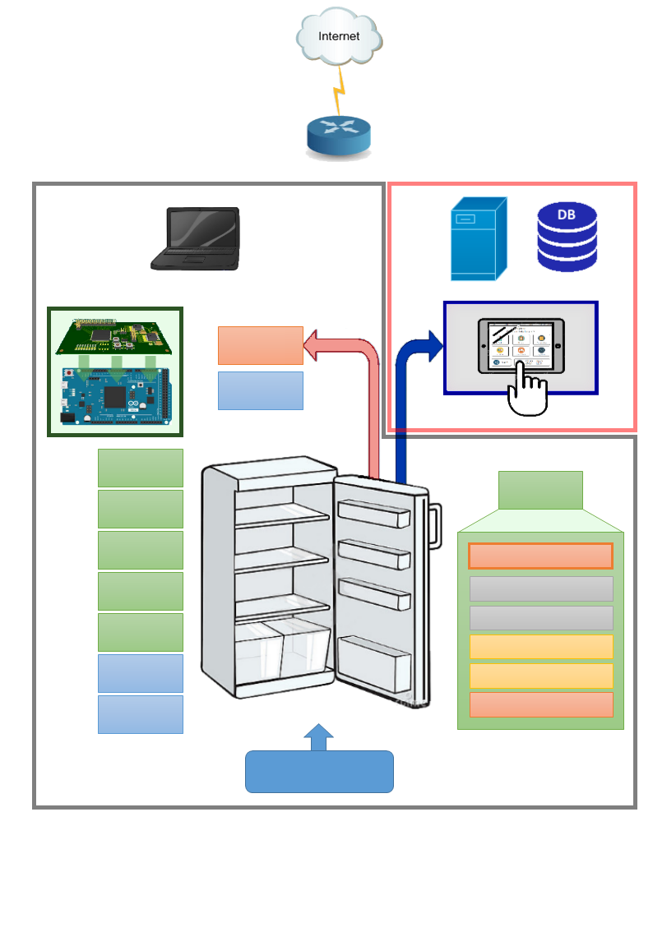After lots of research and discussing about what are the best technologies, and what is realistic in this amount of time we came up with this as the best starting idea:

**...**   
Up to 127 different devices on the same I2C-bus.

(Serial) Level - convertion

RGB - LEDSTRIPS

Addressing + LED driver

NFC reader

Addressing + NFC driver

I2C - Protocol

**Products with NFC-tags**

**Product   
Module 5**

**Product   
Module 4**

**Product   
Module 2**

Server Database

**UI/Server side**

**Embedded side**

**Product   
Module**

Temp. IN 2

Temp. IN 1

**Product   
Module 1**

**Product   
Module 3**

Temp. Out

Motion sensor

Tablet

Custom PCB + DUE

Computer

Router

1. Estimated Gantt-chart:



1. Embedded system

Schema’s   
PCB process  
Troubles and solutions   
I2C   
What I learned  
NFC  
WIFI  
SMD  
Sensors  
Internet of things  
Smart objects  
pie-diagram  
Algorithm!! (time swallowing)   
self-evaluation

Problems:  
Time: Kinect, xTion, Scale, Motionsensor,… 3D-printing, Fault-analyzing/Debug, more problems than expected.   
Level convertsion. UART, MAX232  
Bus system, (took a while when finnaly up and running (stable)   
Interferences on powersuply, by antenna …

# The Annex:

Content:

Will be added soon.

Images:

* Front-page image:   
  <http://www.revistaexclusiva.com/?p=25851>